**Project 3 Design Documentation**

**Computer architecture and organization (CS 520)**

**Summary:**

Base on the 2ed project, project 3 contains several new parts/functions:

1. Renaming table
2. New Forwarding Bus
3. Issue queue
4. ROB
5. New Physical register file & Architectural register file(ARF)
6. Do not realize branching part and LSQ

The new structure in my design:

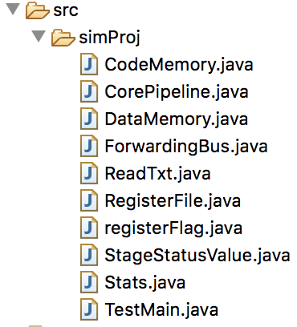

**Note:** How to use project 3 program?

For example, in my case, put the txt test file in this path first.

Then RUN the program. The rest operation should be clear, just follow UI guide.



1. Renaming table is use for allocating the physical register and deallocating the physical register.

Several places use it:

In DRF, allocate physical register.

In ROB + commitment, deallocate physical register.

1. New forwarding Bus

When instruction finish execution in EX_INT/MUL/DU stage, result is forwarding to destination physical register, set ready bit. Then other parts such as ROB, LSQ, IQ will use this value.

1. Issue Q

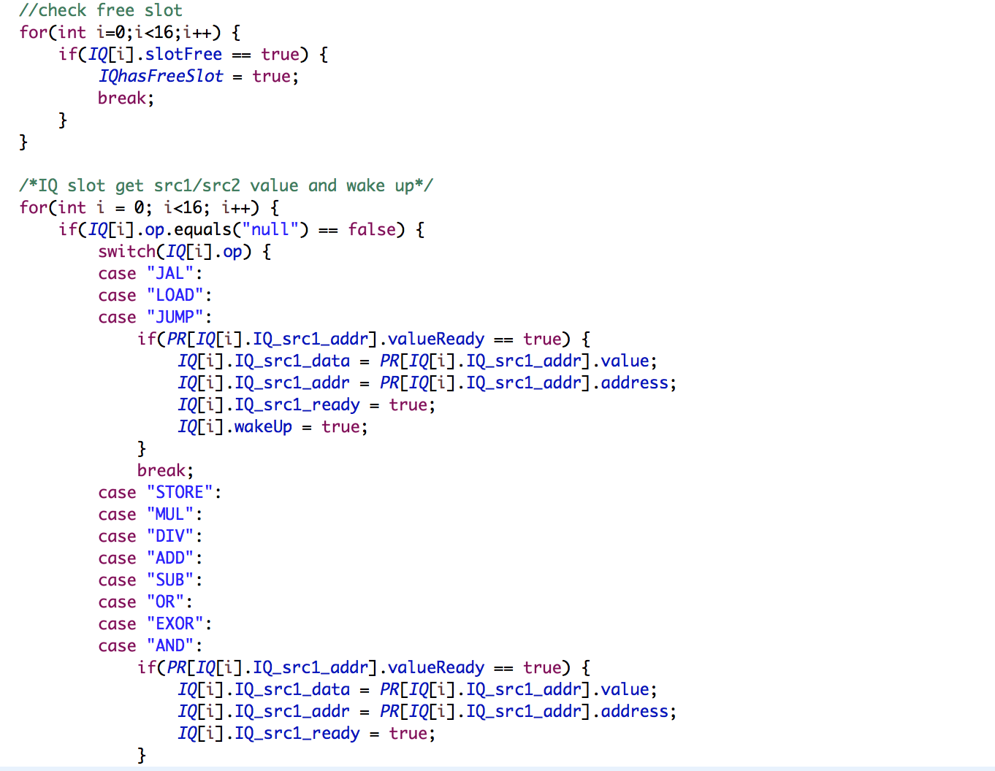

1. ROB

Use ROB, we can get the instructions in programming order.

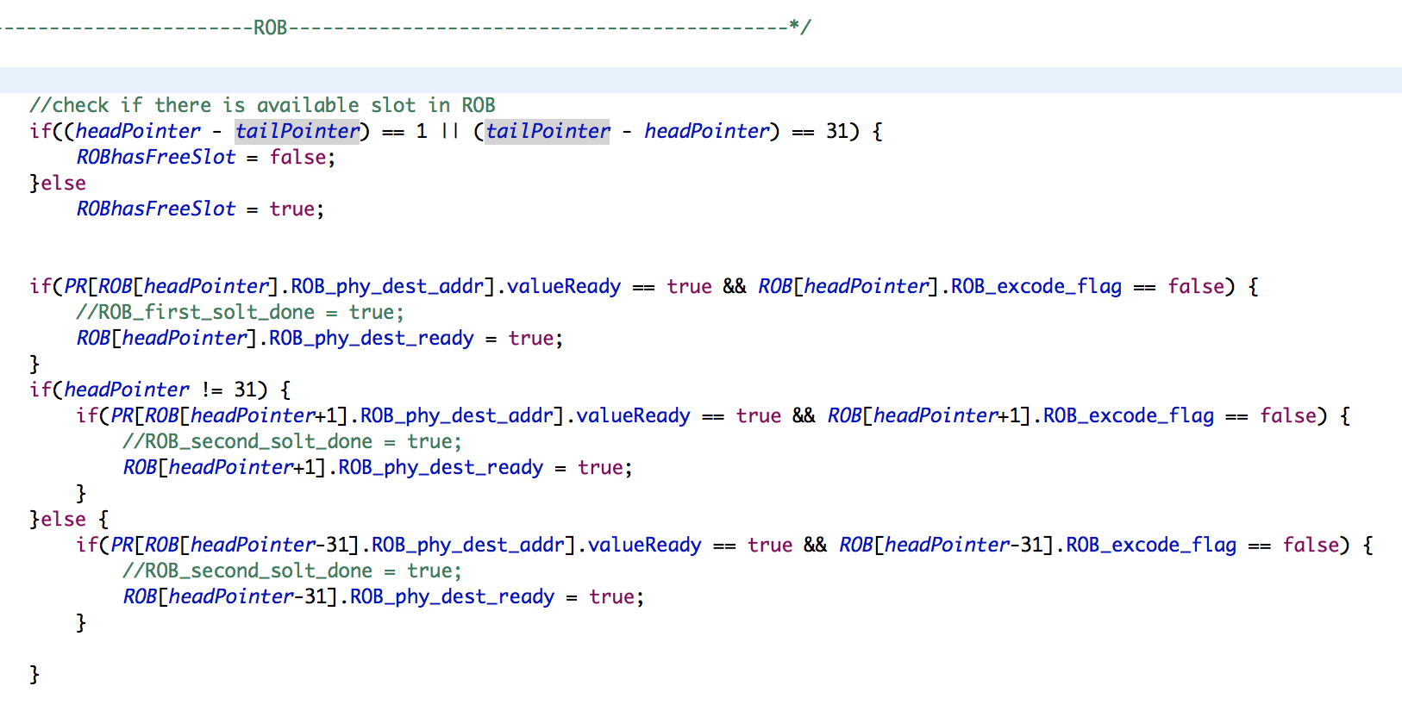

1. New physical register and architectural register

In my design, I use architectural registers as the ARF.